Q1. Create a graph of epoch (x axis) vs. average error (y-axis)

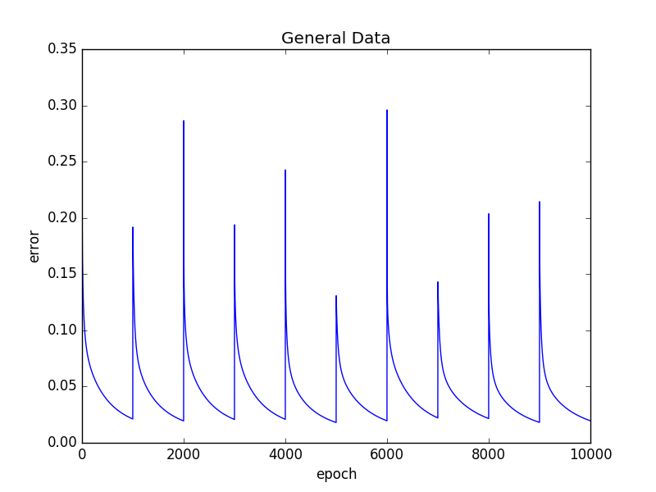

Q2. Use the neural network to learn the function and test it using the **10 fold cross validation method.**

Accuracy = 100.0

Accuracy = 100.0

Accuracy = 100.0

Accuracy = 100.0

Accuracy = 100.0

Accuracy = 100.0

Accuracy = 100.0

Accuracy = 100.0

Accuracy = 100.0

Accuracy = 100.0

Average accuracy: 100.0

**And Gate**

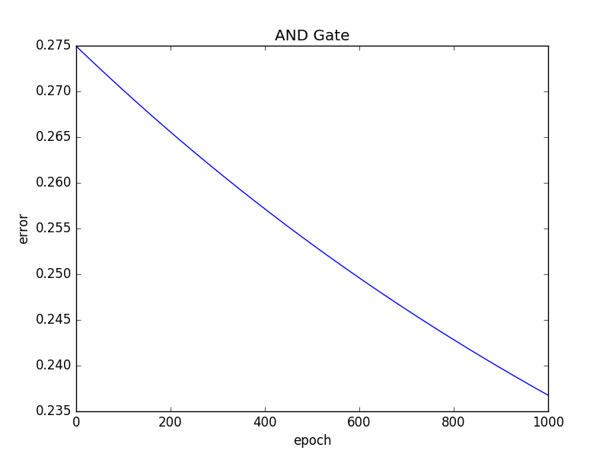

**Or Gate**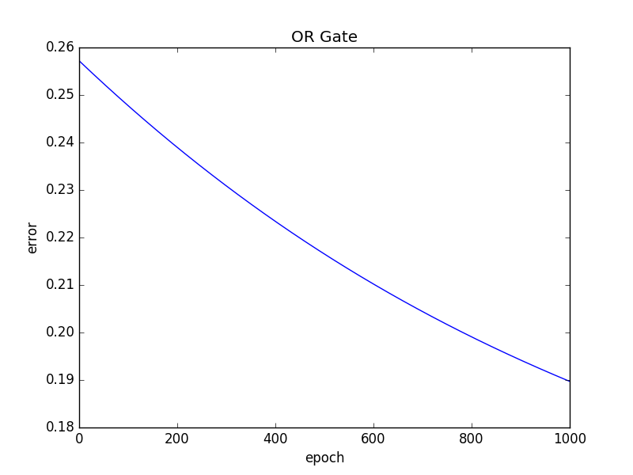

**Nand Gate**

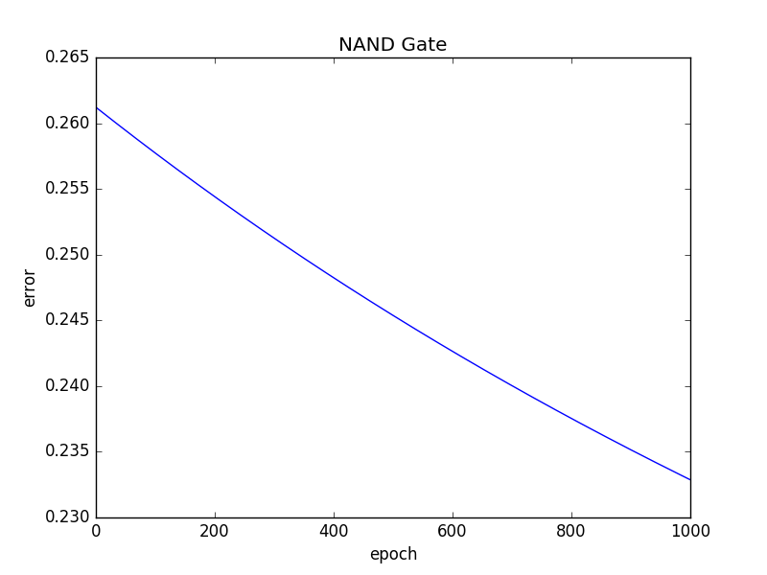

**Nor Gate**

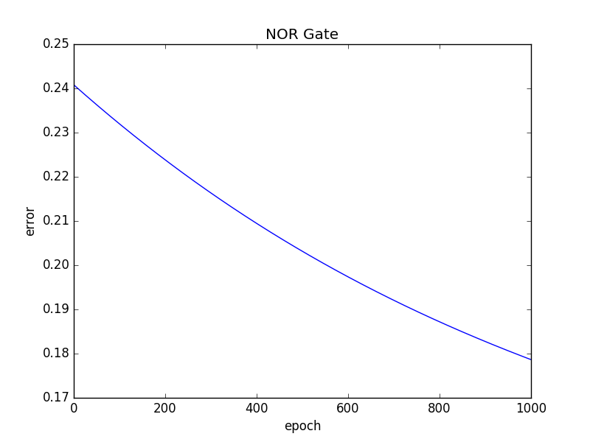

**XOR Gate**

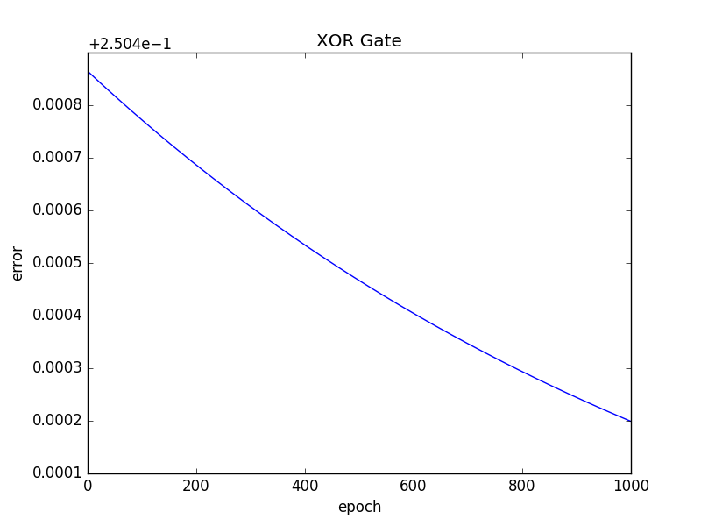

AS we can see in the graph above for the XOR gate. The average error is in exponential terms. It is decreasing as the number of epochs increases. This is because the plot of XOR output is not linearly separable.